- Speaking at events this week, three members of the Monetary Policy Committee largely confirmed our priors about whether they are likely to vote for an August rate cut. Megan Greene's remarks were relatively hawkish. But more dovish sentiments from Andrew Bailey and Dave Ramsden mean we continue to expect a 25bps rate cut in August.
- June's UK flash S&P Global survey supported the case for further policy loosening. The composite PMI was consistent with GDP being flat in Q2, while the balances for costs, prices, and employment all softened.
- Prime Minister Keir Starmer pledged to raise defence spending to meet NATO's new target and appears to have agreed to dilute welfare reforms. Tax rises in the autumn look unavoidable.
In a quiet week for data releases, our attention focused on speeches from three members of the Bank of England's Monetary Policy Committee. This provided an opportunity for these members to shed some light on the spread of views behind the committee's dovish hold last week, and the speeches confirmed our prior beliefs on how each member sees the monetary policy debate unfolding.
Speaking at the Barclays-CEPR Monetary Policy Forum this week, Deputy Governor Dave Ramsden justified his surprise dovish dissent at the June meeting by arguing that the recent emergence of slack in the labour market meant there was now a sufficiently high risk that inflation would settle below the MPC's 2% inflation target without a looser monetary policy stance.
Ramsden put significant emphasis on the latest data from HMRC which indicated that "private sector employee numbers were now clearly in contractionary territory with lower paid sectors particularly impacted by April's rises in employers' national insurance contributions and the national living wage" (Chart 1). We will publish a Research Briefing on this topic next week. The Deputy Governor also warned that recent survey data suggested the slowdown in hiring was likely to continue and that this could result in "a more substantial weakening in the labour market emerging".
Chart 1: The recent contraction in lower paid private sector employment has been particularly marked
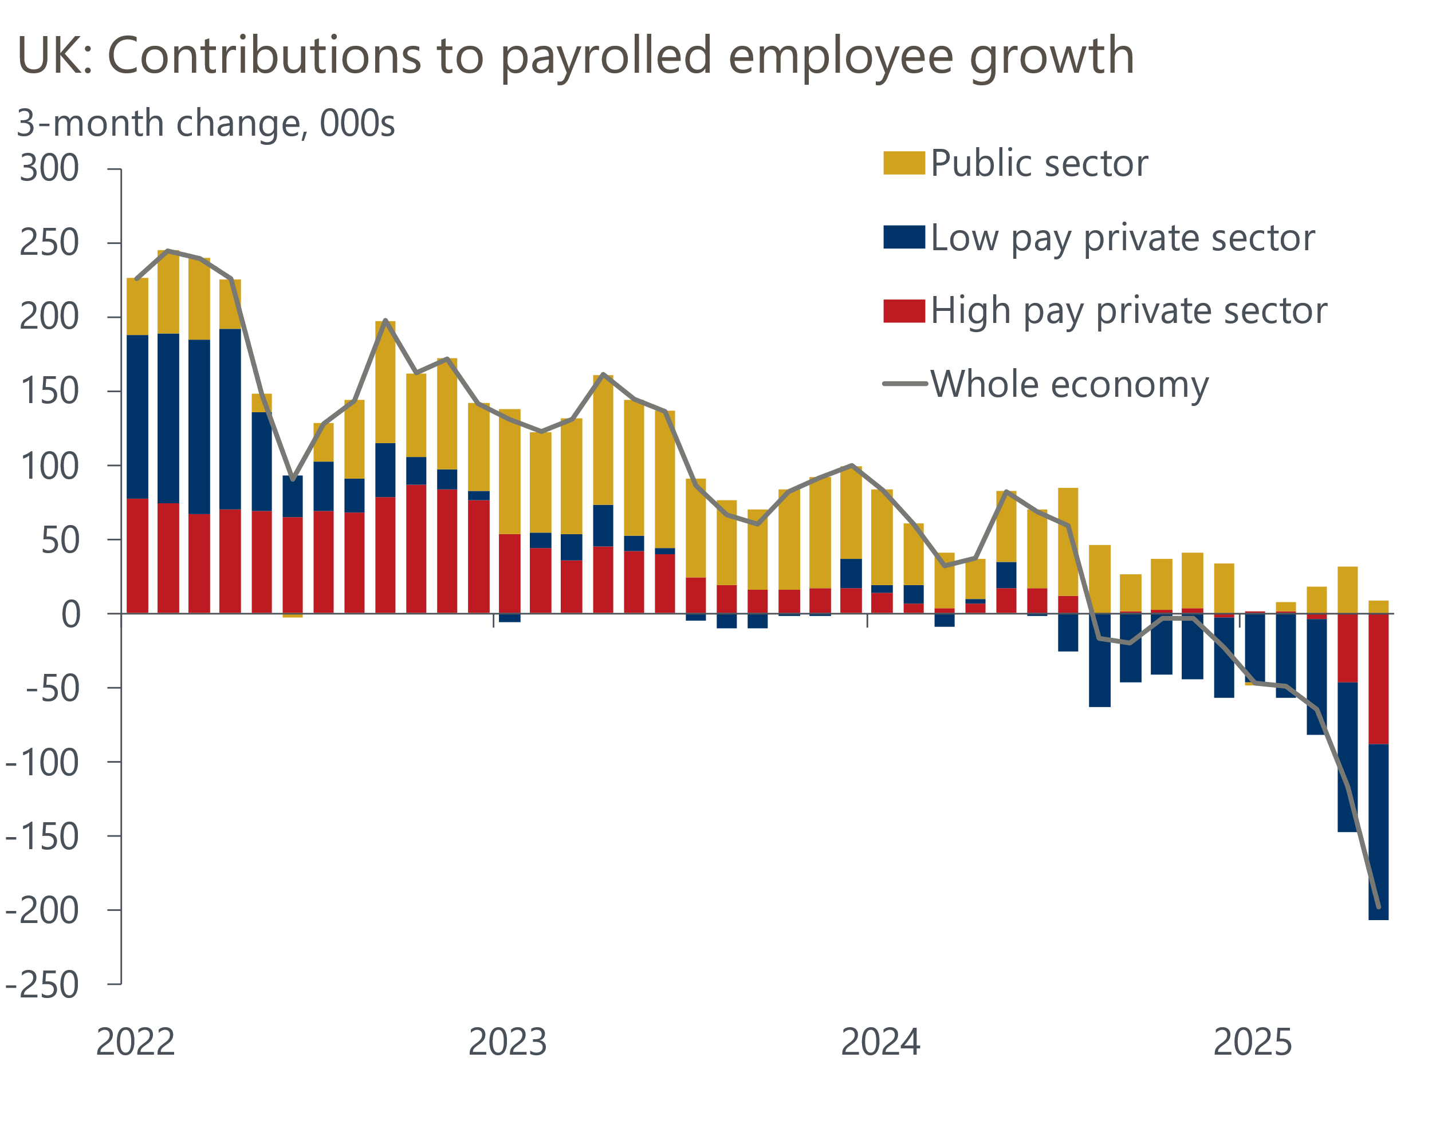
Source: Oxford Economics calculations using Haver Analytics & ONS

In the keynote speech at the British Chamber of Commerce's annual conference, BoE Governor Andrew Bailey suggested that the downward pressure on inflation from a wider margin of slack emerging in the UK economy was also a key factor behind the more dovish tone of June's meeting minutes.
Unlike Ramsden, Bailey provided no explicit steer on how he judged the balance of risks around meeting the committee's inflation target. But the Governor continued to argue that policy remained restrictive and that a "gradual and careful" approach to lowering Bank Rate remained appropriate – language that has so far been consistent with a quarterly pace of cuts. Therefore, provided there are no major upside surprises in next month's labour market and inflation releases, there's a strong likelihood that the Governor will vote for another 25bps rate cut in August.
The results of June's flash S&P Global survey supported the case for further easing. The composite PMI edged up to 50.7 in June, from 50.3 a month earlier, leaving the average for Q2 just below the 50 'no change' mark. This is broadly in line with our view that GDP is likely to have remained flat during the quarter (Chart 2). The flash survey also reported that firms continued to shed jobs in June, while the costs and prices balances softened again.
Chart 2: The composite PMI was broadly flat in Q2, and we expect a similar result for GDP
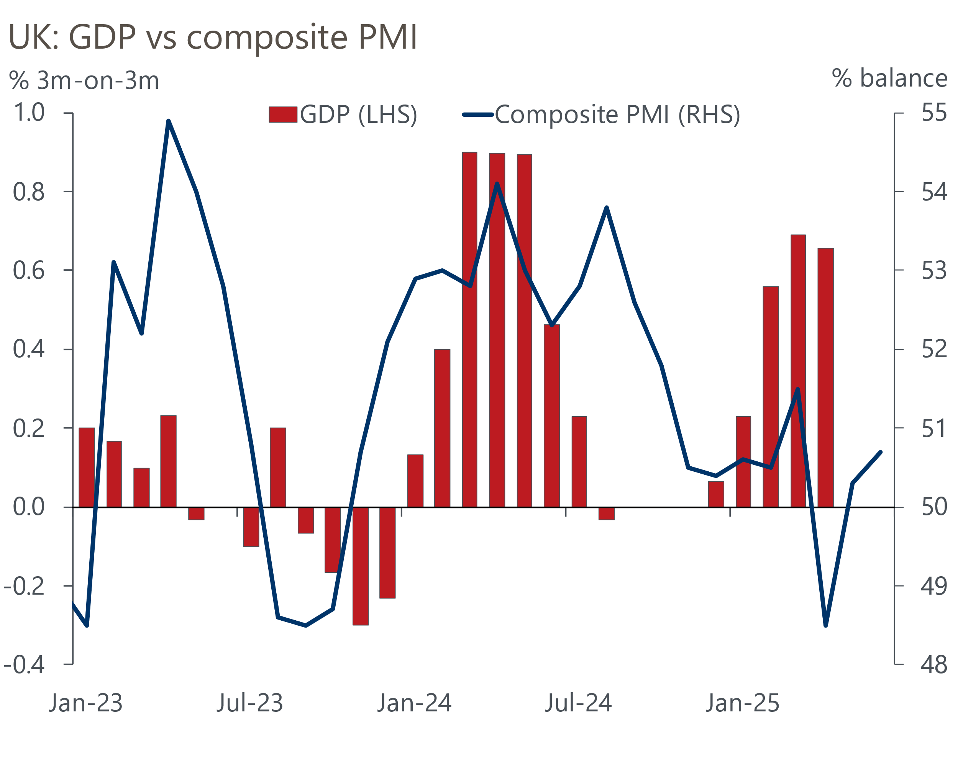
Sources: ONS, S&P Global
Whether external MPC member Megan Greene will support an August rate cut remains unclear. In a speech at the National Institute of Economic and Social Research this week, Greene provided mixed messages on the policy outlook. On the one hand, her emphasis on the potential for elevated inflation expectations to generate further persistence in price-setting sent a relatively hawkish signal. But on the other, similar to Bailey, Greene continued to advocate a "gradual and careful" approach to loosening policy. But with a majority on the committee already likely to vote to cut, Greene's vote is unlikely to be pivotal.
On a separate note, Prime Minister Sir Keir Starmer pledged this week to meet NATO's new defence spending target of 3.5% of GDP on core defence and a further 1.5% on defence-related resiliency and security by 2035. But Starmer offered little detail on how the government's spending plans, which see core defence spending rise to 2.6% of GDP by 2028-2029 and then remain flat, would be adjusted in light of this commitment.
We view a scenario in which defence spending is held at the 2.6% of GDP until the end of this parliament, before suddenly soaring to 3.5% by the end of the next one, as relatively implausible. As well as potentially needing to increase defence spending in the period covered by the fiscal rules, the government is also likely to face extra cost pressures from watering down its welfare reforms. The Spring Statement left a tiny margin for error against the government's fiscal rules, and that will likely be eaten up by the Office for Budget Responsibility revising down its overly optimistic growth forecasts and incorporating new financial market pricing. With every week that passes, tax rises at the autumn Budget look increasingly likely.

The week ahead
Next week will kick off with the release of the Quarterly National Accounts for Q1 2025. This will see the Office for National Statistics take a second stab at estimating GDP, with its initial estimate having shown a strong quarter-on-quarter expansion of 0.7%. The release will also provide the first estimates for household income growth and the savings ratio for Q1.
We expect May's Money & Credit release to show signs that the recent volatility in mortgage lending data, caused by the temporary stamp duty threshold increase finishing at the end of March, is starting to ease. Net secured lending declined in April, due to a sharp fall in gross lending after the stamp duty deadline passed. But we think a recovery in gross lending in May will have pushed net mortgage lending back up to £1.8bn.
Similarly, we expect the downward pressure on mortgage approvals seen over the first four months of this year to have faded in May. As well as the stamp duty distortions starting to ease, a drop in quoted mortgage rates during the month is likely to have gone some way to support demand. Therefore, we forecast that mortgage approvals rose modestly to 61,500 in May, from 60,500 in April.
On the unsecured side, an unusually large fall in repayments more than offset a smaller decline in gross lending in April. We think the weakness in repayments is likely to have unwound in May, but a slump in retail sales that month suggests the scope for a strong pickup in gross lending is limited. As a result, we think net unsecured lending fell to £1.1bn in May, from £1.6bn in April.
Next week also sees the three S&P Global surveys for June released. The flash surveys reported modest improvements in the services and manufacturing PMIs following a pickup in domestic new orders and a less severe contraction in demand from customers abroad. We expect the recent recovery in the construction PMI to have continued in June.
Table 1: Week ahead calendar
Date | Events | Period | Measure | Unit | Previous | Forecast
Jun 30 | GDP | Q1 | q/q | % | 0.7 | 0.7
Jun 30 | GDP | Q1 | y/y | % | 1.3 | 1.3
Jun 30 | Mortgage approvals | May | Level | 000s | 60.5 | 61.5
Jun 30 | Mortgage lending | May | Net lending | £bn | -0.8 | 1.8
Jun 30 | Consumer credit | May | Net lending | £bn | 1.6 | 1.1
Jul 1 | Nationwide house prices | Jun | m/m | % | 0.5 | 0.2
Jul 1 | Nationwide house prices | Jun | y/y | % | 3.5 | 3.5
Jul 1 | S&P Global manufacturing | Jun | PMI | % bal | 4.7.7 | 47.7
Jul 3 | S&P Global services | Jun | PMI | % bal | 51.3 | 51.3
Jul 3 | S&P Global composite | Jun | PMI | % bal | 50.7 | 50.7
Jul 4 | S&P Global construction | Jun | PMI | % bal | 47.9 | 49.0
Source: Oxford Economics

Key forecasts
Table 2: UK forecast overview
(Annual percentage changes unless specified)
 | 2023 | 2024 | 2025 | 2026 | 2027 | 2028
GDP | 0.4 | 1.1 | 1.1 | 0.9 | 1.3 | 1.8
Private consumption | 0.5 | 0.6 | 1.0 | 1.2 | 1.3 | 1.7
Fixed investment | 0.3 | 1.5 | 2.0 | 0.6 | 1.6 | 2.0
Government consumption | 1.6 | 3.0 | 1.5 | 1.7 | 1.6 | 1.7
Exports of goods and services | -0.4 | -1.2 | 1.0 | -0.7 | 1.2 | 1.4
Imports of goods and services | -1.2 | 2.7 | 2.5 | -1.2 | 1.1 | 1.4
Industrial Production | -0.8 | -1.2 | 0.0 | -0.3 | 0.8 | 1.2
Consumer prices | 7.3 | 2.5 | 3.2 | 2.5 | 2.4 | 2.1
Unemployment rate (%) | 4.1 | 4.3 | 4.7 | 4.9 | 4.8 | 4.5
Current a/c balance (% of GDP) | -3.5 | -2.7 | -3.1 | -2.8 | -2.7 | -2.6
Government balance (% of GDP) | 5.2 | 5.1 | 4.3 | 3.6 | 2.9 | 2.6
Central bank policy rate (%, EOP) | 5.25 | 4.75 | 3.75 | 3.00 | 2.50 | 2.50
10yr govt. bond yield (%, EOP) | 3.54 | 4.57 | 4.50 | 3.96 | 3.44 | 3.35
Exchange rate (US$ per £, EOP) | 1.27 | 1.25 | 1.35 | 1.35 | 1.35 | 1.35
Exchange rate (euro per £, EOP) | 1.15 | 1.21 | 1.19 | 1.19 | 1.19 | 1.19
Source: Oxford Economics
Table 3: Quarterly forecasts for the UK
 | 2025 |  |  |  | 2026
 | Q1 | Q2 | Q3 | Q4 | Q1 | Q2 | Q3 | Q4
GDP (% year) | 1.3 | 0.9 | 1.1 | 1.2 | 0.7 | 0.8 | 0.9 | 1.0
CPI inflation (% year) | 2.8 | 3.4 | 3.5 | 3.2 | 3.0 | 2.2 | 2.4 | 2.5
Bank Rate (%, EOP) | 4.50 | 4.25 | 4.00 | 3.75 | 3.50 | 3.25 | 3.25 | 3.00
10yr gilt yield (%, EOP) | 4.70 | 4.70 | 4.61 | 4.50 | 4.37 | 4.24 | 4.10 | 3.96
US$ per £ (EOP) | 1.29 | 1.35 | 1.35 | 1.35 | 1.35 | 1.35 | 1.35 | 1.35
Euro per £ (EOP) | 1.20 | 1.19 | 1.19 | 1.19 | 1.19 | 1.19 | 1.19 | 1.19
Source: Oxford Economics

Latest Country Economic Forecast:
June 17, 2025

Recent publications

Data Insights
Flash PMIs report continued weak activity growth
An autumn fiscal reset remains likely
May's slump in retail sales is payback for earlier strength
Inflation fell in May, after ONS corrected April's road tax error
GDP fell in April, as Q1's strength partially unwound

Research Briefings
MPC’s dovish hold boosts the chances of an August cut
MPC Preview – Divided committee to pause in June
Unconvincing spending review is another fiscal stopgap
Tough fiscal choices looming in the Autumn
What the EU deal means for trade and growth

Contacts

Oxford Economics' UK team
- Andrew Goodwin - Chief UK Economist - agoodwin@oxfordeconomics.com
- Edward Allenby - UK Economist - eallenby@oxfordeconomics.com

